University Of Engineering and Technology, Lahore
Computer Engineering Department

Course Name: Programming Fundamentals | Course Code: CMPE-112L
Assignment Type: Lab Tasks | Dated: 01-05-2026
Semester: 1st | Session: Spring
Lab/Project/Assignment #: 14 | CLOs to be covered: CLO 2
Lab Title: os and main | Teacher Name: Hafiz Muhammad Mubashar
Lab Evaluation:

CLO1 | Apply appropriate programming techniques to create executable programs to solve well defined problems
 | Level1 | Level2 | Level3 | Level4 | Level5 | Level6
(5)
Total |  |  |  |  |  | /5
Rubrics for Current Lab Evaluation
Scale | Marks | Level | Rubric
Excellent | 5 | L1 | Submitted all lab tasks, BONUS task, have good understanding.
Very Good | 4 | L2 | Submitted the lab tasks but have good understanding
Good | 3 | L3 | Submitted the lab tasks but have weak understanding.
Basic | 2 | L4 | Submitted the lab tasks but have no understanding.
Barely Acceptable | 1 | L5 | Submitted only one lab task.
Not Acceptable | 0 | L6 | Did not attempt
LAB No 14
Lab Goals/Objectives:
To learn the use of the os library, the __name__ == '__main__' statement, and the is operator in Python.
Equipment Required:
Computer or Laptop, Python 3.x, PyCharm or VS Code.
Theory:
The os library is used for file and folder operations. The __name__ == '__main__' statement controls program execution. The is operator checks whether two variables refer to the same object in memory.

Lab Work:
Task 1: Use the os library to create and display folders and files.
Result: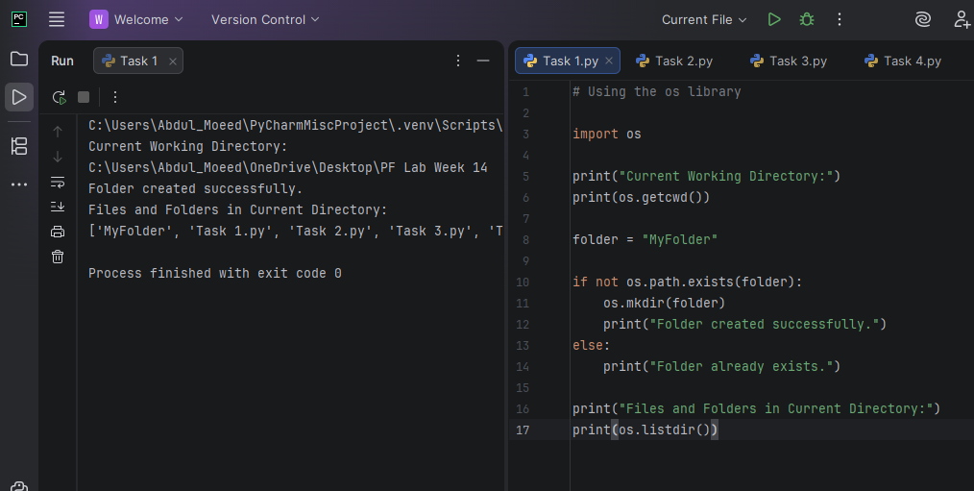

Task 2: Use __name__ == '__main__' to execute program functions.
Result:
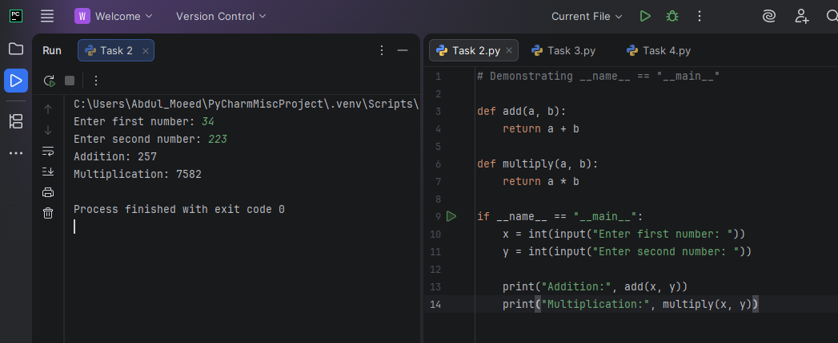

Task 3: Compare objects using the is operator.
Result:

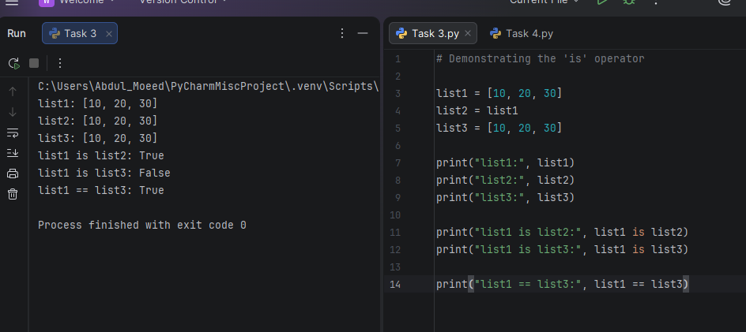

Task 4: Use os, __name__ == '__main__', and is in a single program.
Result: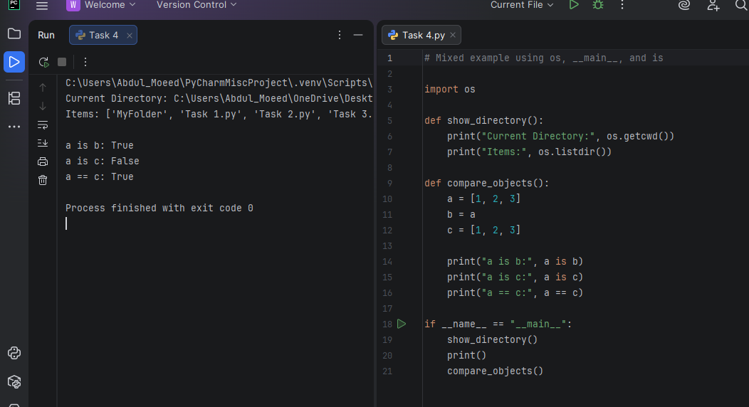

Conclusion:
The lab improved understanding of the os library, the __name__ == '__main__' statement, and the is operator through practical programs.

